Designing an Android application for E-Learning Platform with Augmented Reality: Request for comments.

Sanjay Selvaraj (sanjayspostbox@outlook.com)

**Abstract**

To increase efficiency of learning and to understand clearly about the concepts, augmented reality technology is used to satisfy this. Augmented reality (AR) has been shown to have good potential in making the learning process more active, effective and meaningful. This is because its advanced technology enables users to interact with virtual and real-time applications and brings the natural experiences to the user. In addition, the merging of AR with education has recently attracted research attention because of its ability to allow students to be immersed in realistic experiences.

**Project Proposal**

**1. Introduction**

As Learning and development programs are an ever-evolving component in human resources, I choose to do a learning app with augmented reality integration named **learn AR** for school students. In this app, I am the user to learn and develop their skill with hands-on activities which combines supervision, interaction, and engaging tasks so that, user can able to learn their topics with AR integration where AR superimposes the digital contents what user learns into the real world, allowing users to view and understand the topics even deeper.

Following are key points in my project proposal:

* Market Research and Motivation
* Overview
* Background and Summary of the intended product.
* Competitor Analysis

**1.1) Market Research and Motivation:**

There are several AR apps for learning in the market. In that, I came up with few applications which are likely more interested in kids and used widely. Firstly, I would like to say about the app named **Quiver Vision[1]**. This application is mainly used for coloring purposes. This application uses coloring images as target images where the students can able to color the image and can able to see the colored image as a 3d model while scanning colored one. Secondly, I would like to say about the app named **Arloon Plants[2]**. This app lets the students explore the plants to learn detail about their parts and structure. With this app, students can grow and move to their desired place in the AR experience by scanning the floor as the target image.

The motivation for this app came from my struggles faced during my school days where I couldn’t able to understand some topics clearly. And also, I was very much eager to learn topics about space in virtual effect. My interest and struggles made me choose this app.

**1.2) Overview:**

My app **learn AR**, has good looking and understandable UI where students can able to feel the app user friendly. As soon as the app gets installed, students will be finding sign-in and sign-up pages. After completing the sign-in/sign-up process, they will be finding several topics which will be listed one by one. Students then will be able to select their desired topics and will be able to learn the topics with AR in detail. They can able to rotate the AR content in 360 degrees. And they can able to zoom in and zoom out the AR content.

For example, In topics such as the solar system where students will be able to view the entire solar system as AR content (AR content here is 3d model). And students can also zoom in to view any one of the planets to learn in detail. They can also able to rotate the planets as they needed so that they get know about the poles of the planets in even more detail.

**1.3) Background and Summary of the intended product:**

Integrating immersive technologies like augmented reality in education improves learning efficiency and it is more effective to teach students than compared to other media such as books, lectures, and videos. AR in learning brings the students long retention and deeper understanding of the concepts. Students will not be feeling bored during they learn and interaction and participation of students will be massive. Hence, there will not arise any problems like lack of memory about the concepts and less interaction of students.

And my app **learn AR** will nurture the students and will be improving the learning process and enhancing the learning environment more effectively. Learn AR takes students to the future and past.

**1.4) Competitor Analysis:**

1.4.a) Curiscope’s Virtuali-Tee[3]:

The main theme of this AR application is to make students learn about human anatomy and describes the structure of each organ in the upper human body. For this, Virtuali-Tee designs the T-shirt where the code will be embedded on the front face of the shirt. And this designed T-shirt should be worn by students for AR experience or can be kept simply on the table or floor. The front face of the shirt containing the code will be acting as the target image here. Once installing the app, human anatomy will appear in AR while scanning the T-Shirt code. Students can move the tablet/phone device around and zoom in/zoom out to inspect the organs and bones for deeper understandings. This app will function only when the user has the designed T-shirt code. This will not be effective when students miss or lose their designed code T-shirts. And also, this application describes only the upper body of the human anatomy because code T-shirt covers only the upper body part.

1.4.b) Catchy Words[4]:

This application is completely based on the ios operating system. The main theme of Catchy Words is to make the kids learn spellings or correct spellings and to improve their verbal knowledge. After installing Catchy Words[4], students should walk around their room or environment where they stand. Then, the application shows some of the alphabets somewhere in the room. Once the camera gets closer to the alphabets shown, it gets collected, and then it moves for searching another alphabet. This process continues for several alphabets. Later collecting all alphabets, students can able to arrange the alphabets so that arranged alphabets can come up with learning new English words.

The main disadvantage of this application is, it contains only limited words to arrange and learn. This makes the students get bored after limited usage

1.4.c) 3D Bear[5]:

The main aim of this application is to learn types of shapes, animals, birds, etc. This 3D Bear[5] lets students create their own AR experience by placing the 3d models in their environment. This application consists of too many mads. And this is not completely on the educational side. This also allows creating 3d models to experience in AR.

This 3D Bear[5] consists of improper UI which makes it complicated to understand for the layman.

**2. Features:**

Learn AR contains Sing-in/Sign Up pages. So that students can able to view their courses respective for their classes. I have used simple and attractive UI with minimalistic options so that students can adapt and use the app more effectively and efficiently.

Following features are taken into account in this project proposal document:

* Asset list
* Product purpose
* Complex components, User stories, UI/UX design
* Function flow of Learn AR

**2.1) Asset list:**

**2.1.a) Components:**

* **Figma** – It is an open-source tool where I can share my files and lets the team share works and libraries very easily without complications. I used the Figma tool for UI designing, wireframing and for basic.
* **Adobe Illustrator** – I used this tool for creating a logo for Learn AR. This tool creates the files in manageable sizes and also it allows for In-panel editing.
* **Github** – It is completely free and open source. I have created a separate repository and stored my code to maintain.
* **Android Studio** –This IDE is optimizable for all android devices. I used this tool for developing my android application. With Android Studio we can configure I can configure my builds without any limits.
* **AR Core** – It is the core SDK for creating augmented reality applications in android studio. Along with that, sceneform API is used to render 3D scenes in augmented reality. And also, it acts as the plugin for importing and building 3d assets. I imported AR Core inside the android studio to integrate AR experience in my application.
* **Android Studio Emulator**- I tested my application with an inbuilt Android Studio Emulator because I need not go with external testing software to test my application.
* **Java** – I used java programming language for creating my application. Java is very easy to use, compile and debug code. It interprets the errors line by line.
* **MySql** – I used this tool for maintaining databases. Databases used in this application are very less as because I have maintained only login details.

**2.1.b) Pages in my application:**

Learn AR contains eight pages. I have used a white theme for all eight pages. I have created a simple and attractive user interface that makes students feel much easier while using my application.

Following are the pages created for my app **Learn AR:**

* **Splash Screen** – This splash screen is designed to appear first when the students install and open my application Learn AR. This page contains minimal designs with the logo of Learn AR. Only pleasant colors are used on this page. After a while, this page gets disappeared and automatically navigates to the Sign-in page.
* **Sign-in page** – The Sign-in page for Learn AR contains two fields where the registered students can enter their respective email and passwords. And also, it contains the link which navigates for the signup page where the non-registered students can able to register.
* **Signup page** – The Signup page for Learn AR contains three fields where the non-registered students can enter their respective name, mail id and they can set a password. Validation for the password is also created on this page. And the final button named Sign up at the end of the form is created to submit the details once after entering.
* **Settings page** – This page is mainly created for editing purposes. Details of the student-submitted while creating the account in Learn AR will be viewed on this settings page. In case of any changes in submitted details of the submitted can be made on this page.
* **Profile Page** – On this page, the student's profile photo can be updated and edited. This page contains information about courses students have registered for. Course information such as the number of courses they enrolled in and the progress of the courses can be viewed on this page. And the courses they wished to register for will be available in the saved option.
* **Courses page** – This page lists all the courses available to learn and it has an additional option called enroll where students can enroll them in the respective courses for learning. And also, students will be able to find the registered courses and they can able to enter into their courses to learn by clicking an option called to go to course.
* **Registered Course Page** – Students will be navigated to this page after clicking an option to go to the course in courses page. This page contains all the necessary things for the course which includes course description, course content, and course information. An external Option is created in this called View in AR where Students can able to view the 3D models in the content of the course.
* **AR Page** – When the option called View in AR is clicked by the students, the registered course page will navigate to the AR page. Once this page gets opened, a popup message will be shown to access the camera controls of the device. Then camera detects the floor of the environment and places the 3D models in the course content. Students can able to rotate 3D models in 360 degrees. And also, students can able to Zoom in/Zoom out the 3D models to know extra details of the 3D models.

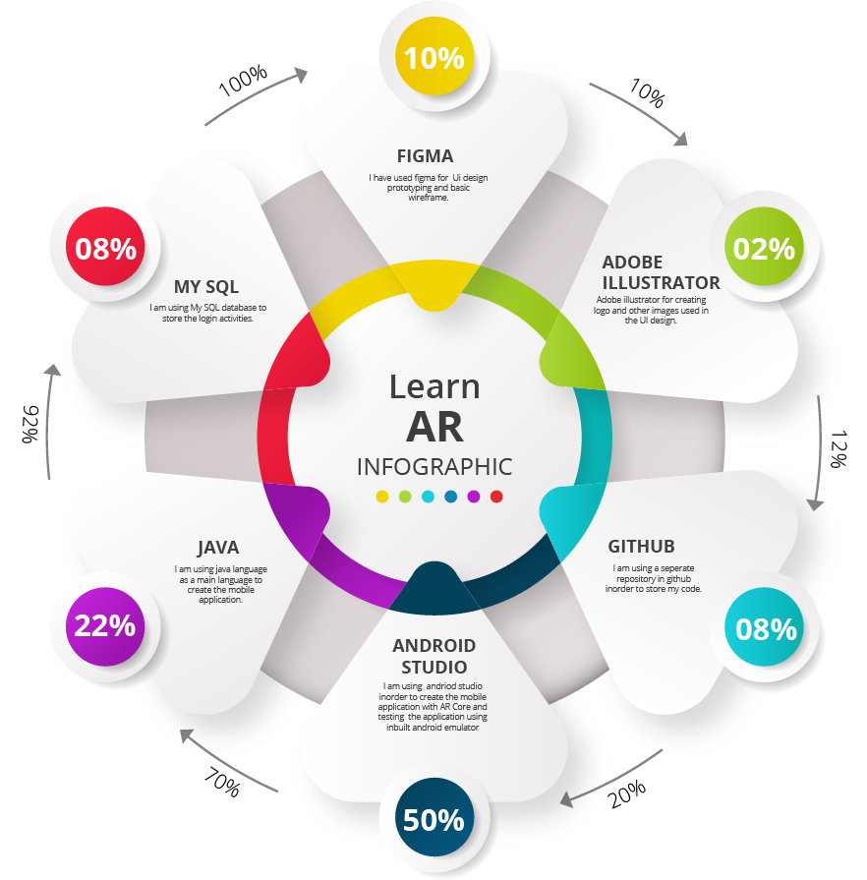

**2.2) Product Purpose:**

**2.2.a) Target Audience:**

The purpose of Learn AR explains what Learn AR is and why it is worth using and its features. The most important and intended user of Learn AR is school students. Augmented Reality representation helps the students to understand the concepts much deeper on comparing representing in theory format and other media platforms such as video representation or smart class-oriented teaching. My app Learn AR will be appealing to the students as this will be helping to learn the concepts very effectively so that, students will not be facing the problems such as forgetting the concepts, and also, it enhances the learning environment and methodology. My Learn AR app will be helpful for at least 1000 students in an educational institution to understand the concepts better. This gives the fast learning of concepts to students.

**2.2.b) Creativity of the application:**

My app Learn AR is created by using a current trending technology called augmented reality where students can able to think innovatively by understanding and viewing the concepts in AR. And this increases the thinking ability of the students so that students can achieve their goals easily. By using this new trending technology AR, students will not find any difficulties to learn and the learning methodology will be an entertaining one.

**2.3.a) Complex components:**

* **AR core** - SDK version should be the same as the AR core version while integrating AR Core.
* **Android version updates** - If any changes in the build number due to updates in the android version, the app will be crashed. And to overcome this problem, publishing the update for the respective build number should be made
* **Sceneform API** - Importing 3D models should be in the right file formats such as .obj, .fbx, .sfb and etc. Materials and shaders needed for the 3D model should be linked and exported with 3D models correctly.

In the case of re-importing materials for 3D models will not be possible in the sceneform. This must be done where the initial process of exporting 3D models took place with the correct file format.

**2.3.b) Guidelines for user stories:**

The main point which needs to be taken into account while creating user stories is, It should be completely based on Real-life scenarios from the user's point of view or customer point of view.

It should always start with a word called ‘AS’ from the side of user role or customer role followed by mentioning the user's goal to be accomplished and should also mention reasons of the goal from the user side. Some pre-condition should be mentioned while user expects for the result when they do some action.

**2.3.c) Guidelines for UI/UX design:**

* A UI/UX design should contain or satisfy the all basic requirements of the user.
* An application should always contain simple and consistent UI/UX design.
* User should know what is going on or what is happening while making actions on UI options like hitting on buttons and options.
* Information needed for application should be simple and concise.
* After completing the UI/UX design process, testing the designed UI/UX design should be done with one of the users.

**2.4) Function flow of Learn AR:**

Function flow of any application describes the process and actions done when the user launch the application in mobile/tablet devices and they start to use the application.

Mainly working process and what to be done next of any actions will be discussed in the function flow of the application. I Covered all the workflow functions needed for Learn AR and came up with a representation in the flow diagram as follows.

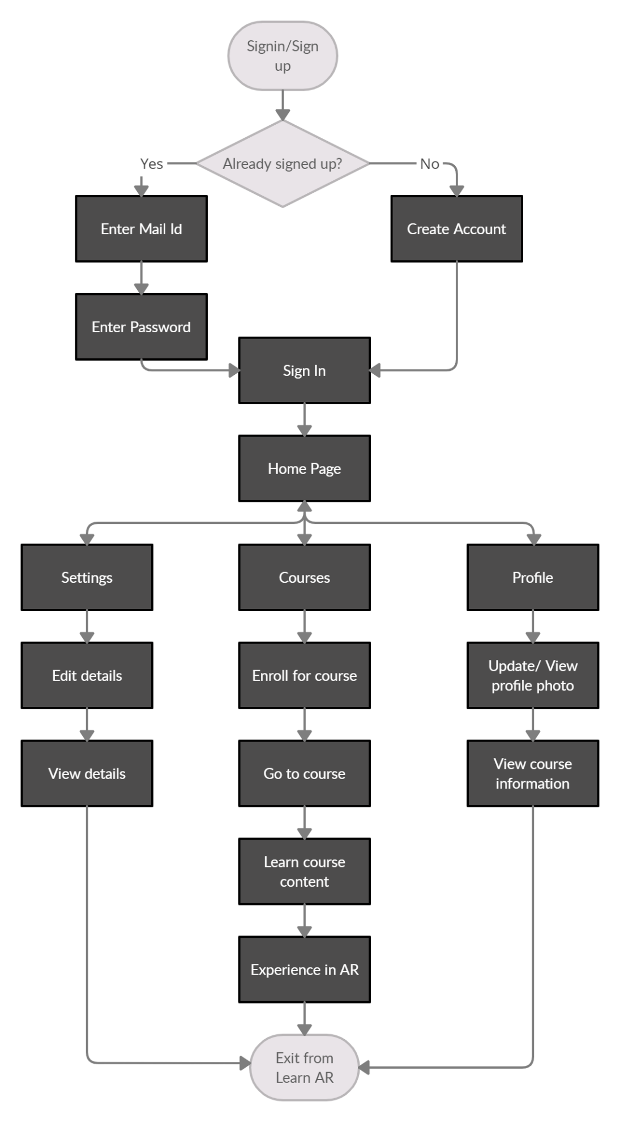

* Initially, the sign-in/sign-up process should be done by the students. They are required to enter their mail id and password when they sign in to Learn AR. And for sign-up, students are required to create an account in Learn AR.
* After completing Sign in/ Sign up process, students will be navigated to the home page where they will be finding several options called settings, profile and courses.
* When the students do actions on the settings option on the home page, they will be navigated to the settings page where they can edit and update their entered mail id and name done in the sign-up process.
* When the students do actions on profile options on the home page, they will be navigated to the profile page where they can edit and update their profile photo and students can able to see the details about registered courses.
* When the students do actions on the course option on the home page, they will be navigated to the course page where they will be finding course details, course contents, and an additional option called ‘View in AR’.
* When the students navigate to the View in AR page, students will be receiving a popup message to give access to the camera on mobile/tablet devices. The camera in devices detects the floor of the environment. Then the 3D model in course content will be displayed in AR.

**2.4.a) Feasibility:**

All the above-mentioned function flow are feasible in developing the product, as the assets and components needed for this app development are open source and don’t require any paid software. As the tutorial resources are found for dealing with my complex components like importing AR core SDK and checking with android version. And also, for importing correct materials and shaders for 3D models. So, implementing all the function flow in my Learn AR can be completed within the allocated time

**2.4.b) Analysing function flow of learn AR:**

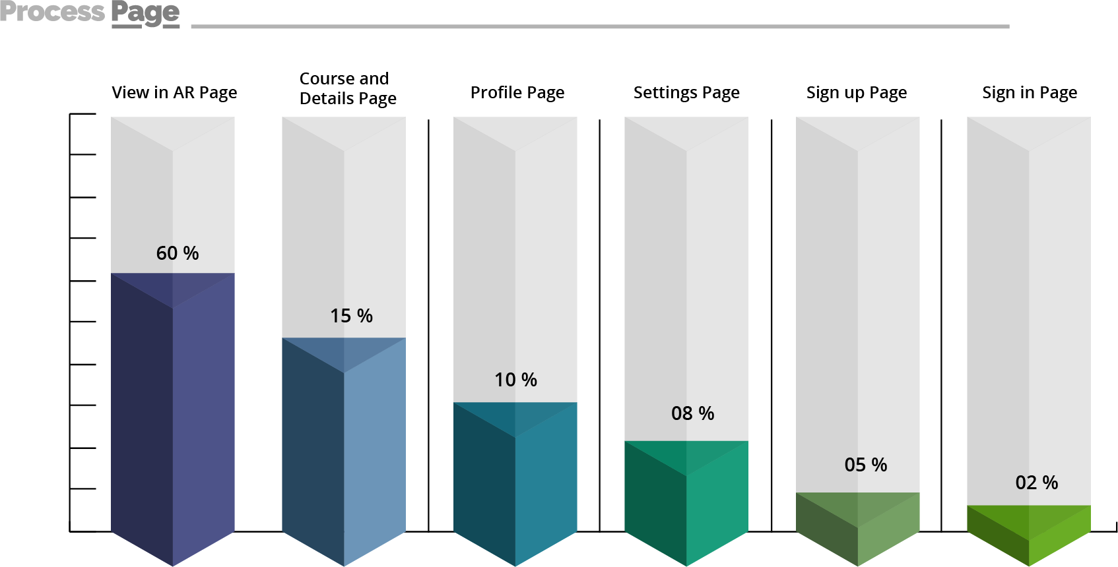

As per analysis, the user will be engaged more in using the view AR page on comparing to all other pages. Minimalised used pages are signed in and sign up pages and this process will not be repeated often until the user logs out or uninstalls the application. Then the settings and profile page comes under moderate usage. This will be required only when the changes have to be done in their details and course information. The course page will be used slightly less than the AR page to know course details and to learn course contents.

**3) Milestones:**

**Week 1-4:**

* Researching about the current application which are similar to Learn AR.
* Creating a simple and attractive UI design using figma tool
* Preparing project proposal by covering all the necessary topics for Learn AR.

**Week 5:**

* Creating Sign in/Sign Up page in android studio as per the designed UI.
* Linking the databases in order to save the user credentials.
* Validating the user Sign in/ Sign Up pages.

**Week 6-9:**

* Creating and exporting the 3D models from 3D max.
* Importing and rendering the 3D models in the android studio using sceneform API.
* Creating course page, profile page and settings page as per designed UI.

**Week 10-11:**

* Creating the final View in AR page using AR Core SDK.
* Testing the application in the inbuilt android emulator and fixing the bugs.
* Deploying the final AR application for the user purpose.

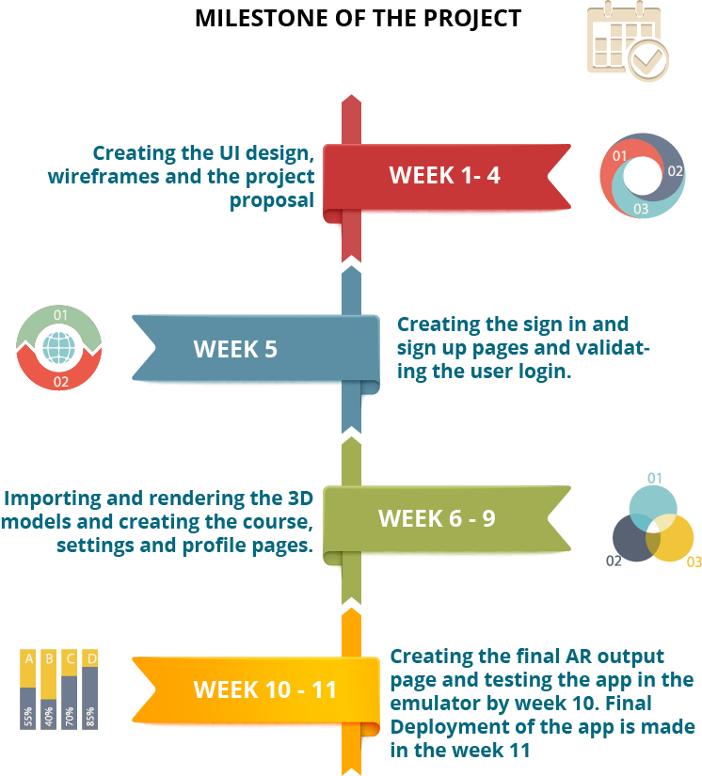

**4) Detailed UI/UX design:**

**4.1) User Stories:**

**User story -1**

|  |  |  |  |
| --- | --- | --- | --- |
| **Statement** | **Acceptance Criteria** | **Estimation** | **Priority** |
| **As a fresh user, I should complete sign Up process and then enter into the Learn AR by signing in** | 1) Initially user will be navigated to sign in page.  2) User will be finding Sign up option where they can enter their details and create the account.  3) After creating the account, user can enter their details in order to sign in. | By using planning poker technique to estimate the story points.  **Story point: 8** | Priority: 1  **High priority** |

**User story -2**

|  |  |  |  |
| --- | --- | --- | --- |
| **Statement** | **Acceptance Criteria** | **Estimation** | **Priority** |
| **As a registered user, I want to edit my details in profile page if needed.** | 1) By clicking the profile option in home page after signing in, user should navigate to profile page.  2) After navigating to profile page, user should able to edit and update the details as per their convenient. | By using planning poker technique to estimate the story points.  **Story point: 5** | Priority: 1  **High priority** |

**User story -3**

|  |  |  |  |
| --- | --- | --- | --- |
| **Statement** | **Acceptance Criteria** | **Estimation** | **Priority** |
| **As a user, I should able to search and enroll for a course in the course page.** | 1) Initially user should search for a course with a keyword.  2) User should able to view list of the courses matching for search result.  3) Finally, user should able to enroll the course by clicking enroll button. | By using planning poker technique to estimate the story points.  **Story point: 8** | Priority: 1  **High priority** |

**User story -4**

|  |  |  |  |
| --- | --- | --- | --- |
| **Statement** | **Acceptance Criteria** | **Estimation** | **Priority** |
| **As a user, I should able to view my course progress and able withdraw from the courses enrolled in profile page.** | 1) By clicking the profile option in the bottom of the screen, user should be navigated to profile page.  2) User should able to view the enrolled courses in the profile page.  3) User should able to withdraw from the course which is available in profile page. | By using planning poker technique to estimate the story points.  **Story point: 8** | Priority: 1  **High priority** |

**User story -5**

|  |  |  |  |
| --- | --- | --- | --- |
| **Statement** | **Acceptance Criteria** | **Estimation** | **Priority** |
| **As a user, I should able to view the course contents in AR.** | 1) User should able to view the course contents and course details.  2) User should able to click the view in AR option in order to experience the course contents in AR.  3) Users device should on the camera and should detect the floor of environment and should place the AR Content on the floor. | By using planning poker technique to estimate the story points.  **Story point: 8** | Priority: 1  **High priority** |

**4.2) Use case:**

I have covered all the use cases needed for my app Learn AR from user side and admin side. The basic functions like editing, updating and viewing the cases are included in the use case diagram.

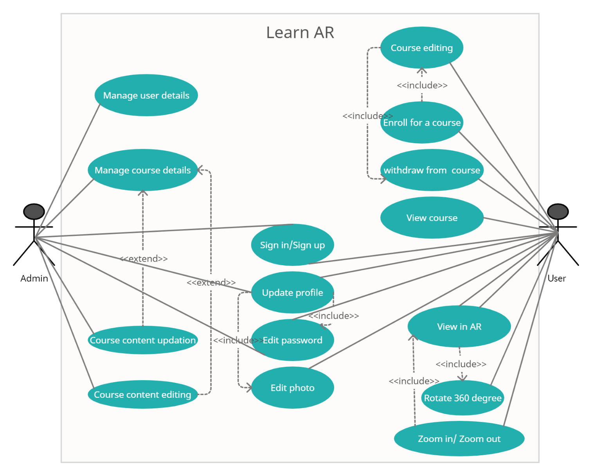

**4.3) UI/UX Design:**

I have used figma tool to design UI/UX. I have attached the link for my UI/UX design below.

<https://www.figma.com/file/0tDjHBBDaeHJ16bFAZXLUK/UI-LEARN-AR?node-id=0%3A1>

**5) High Level Wireframes:**

To create High Level Wireframes, I have used figma tool. I have created wireframing totally for 8 pages. Links between the pages are shown by using arrow marks.

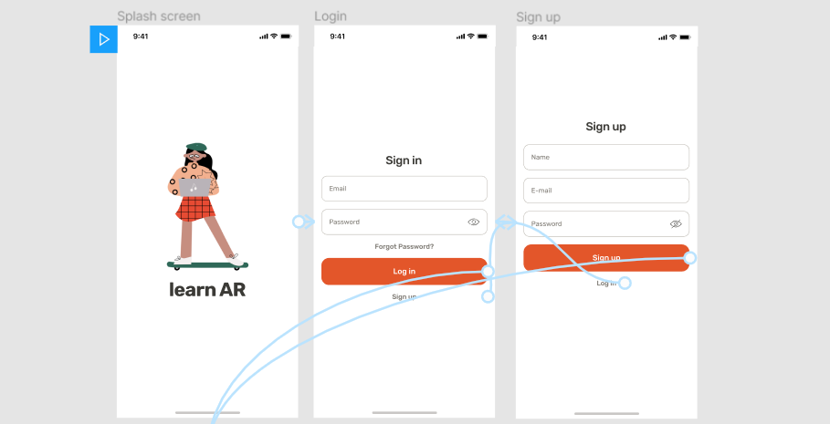

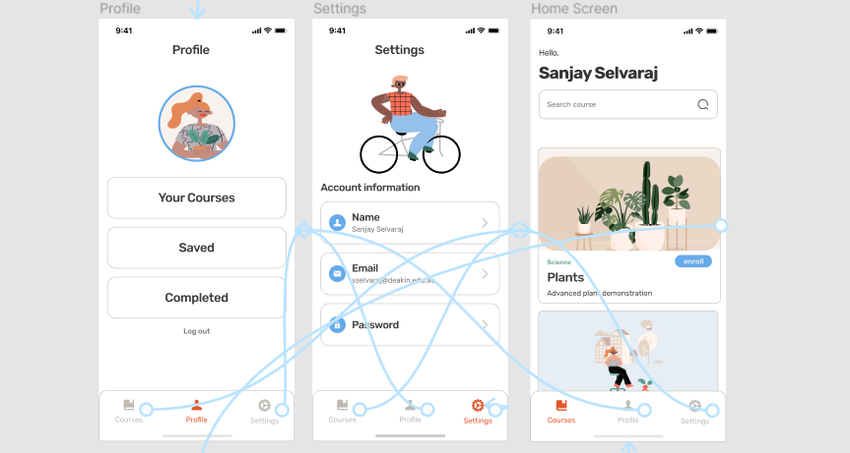

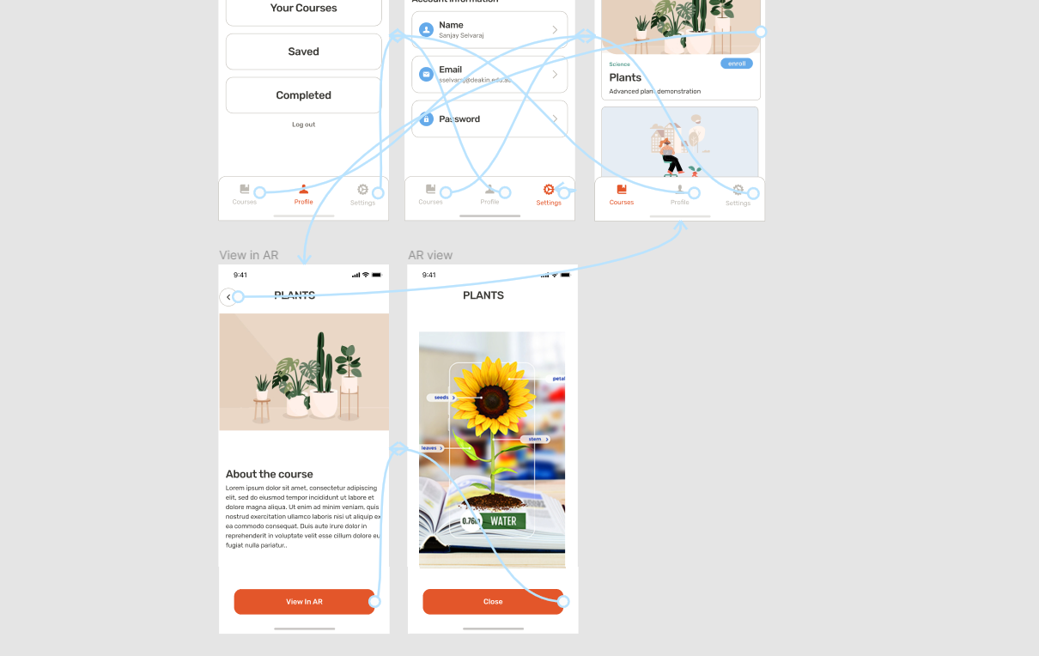

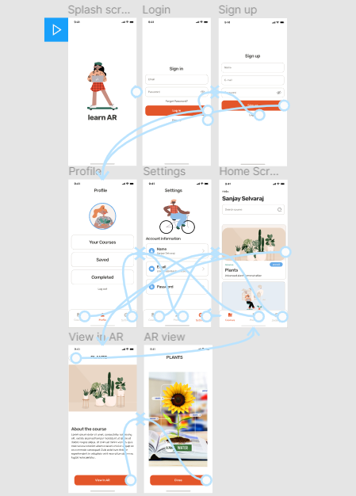

**6)Performance analysis and future directions:**

We will perform rigorous testing of our applications over transport layer protocols including TCP[6] and multipath TCP[9], among others over widely used Wi-Fi and cellular networks, for future enhancement we will seek ways to plug and play apps for advancements in distributed computing such as a federated learning[7,8] and distributed ledger.

**References:**

[1] **Quiver Vision**

[**https://quivervision.com/**](https://quivervision.com/)

[2] **Arloon Plants**

[**http://www.arloon.com/en/apps/plants/**](http://www.arloon.com/en/apps/plants/)

[3] **Curiscope’s Virtuali-Tee**

[**https://www.curiscope.com/**](https://www.curiscope.com/)

[4] **Catchy Words**

[**https://apps.apple.com/us/app/catchy-words-ar/id1266039244**](https://apps.apple.com/us/app/catchy-words-ar/id1266039244)

[5] **3D Bear**

[**https://www.3dbear.io/3dbear-academy**](https://www.3dbear.io/3dbear-academy)

[6] Pokhrel, Shiva Raj., et al. "TCP Performance over Wi-Fi: Joint Impact of Buffer and Channel Losses." *IEEE Transactions on Mobile Computing* 15 (2016).

[7] Pokhrel, Shiva Raj, and Jinho Choi. "Improving TCP performance over WiFi for internet of vehicles: A federated learning approach." *IEEE Transactions on Vehicular Technology* 69.6 (2020): 6798-6802.

[8] Pokhrel, Shiva Raj, and Jinho Choi. "A decentralized federated learning approach for connected autonomous vehicles." *2020 IEEE Wireless Communications and Networking Conference Workshops (WCNCW)*. IEEE, 2020.

[9]Pokhrel, Shiva Raj, and Carey Williamson. "A Rent-Seeking Framework for Multipath TCP." *ACM SIGMETRICS Performance Evaluation Review* 48.3 (2021): 63-70.